Contents

1. Sales Document Types(VOV8): 3

1.1 Standard order 3

1.2 Consignment Fill-up 1.3. Consignment Pick-up 4

1.4 Consignment Issue(ZKE) 1.5 Consignment Returns(ZKN) 5

2. Item category(VOV7) 6

2.1 Print Product(ZPRT) 6

2.2. Third-party item 2.3. Milestone Billing(ZBAO) 7

2.4. Subscription(ZTBD) 2.5. Direct Drop-shipment 8

2.6. Consignment Fill-up(ZKBN) 2.7. Consignment Issue(ZKEN) 9

2.8. Consignment Returns(ZKRN) 2.9. Consignment Pick-up(ZKAN) 10

2.10 Return Item(ZPRN) 2.11 Service Product(ZSER) 11

3. Schedule line categories 12

3.1 Third-party(CS) 3.2 Print(CP) 12

3.3 Consignment Pick-up(ZKAN) 3.4 Consignment Fill-up(ZKBN) 13

3.5 Consignment Issue(ZKEN) 3.6 Consignment Return(ZKRN) 14

3.7 Digital (ZTBD) 3.8 Downpayment(ZTEC) 15

4. Billing Types(VOFA) 16

4.1 Invoice(ZF2) 16

4.2. ZBV(OUP Cash/ CC Invoice) 18

4.3 Downpayment request(ZFZ) 21

4.4 Credit Memo(ZG2) 22

4.5 Intercompany Invoice(ZIV) 23

4.6 Invoice Cancellation(ZS1) 24

# Sales Document Types(VOV8):

## 1.1 Standard order

# A screenshot of a computer Description automatically generated1.2 Consignment Fill-up 1.3. Consignment Pick-up

# A screenshot of a computer Description automatically generated1.4 Consignment Issue(ZKE) 1.5 Consignment Returns(ZKN)

# 2. Item category(VOV7)

## 2.1 Print Product(ZPRT)

## 2.2. Third-party item 2.3. Milestone Billing(ZBAO)

## 2.4. Subscription(ZTBD) 2.5. Direct Drop-shipment

## 2.6. Consignment Fill-up(ZKBN) 2.7. Consignment Issue(ZKEN)

## 2.8. Consignment Returns(ZKRN) 2.9. Consignment Pick-up(ZKAN)

## 2.10 Return Item(ZPRN) 2.11 Service Product(ZSER)

# 3. Schedule line categories

## 3.1 Third-party(CS) 3.2 Print(CP)

## 3.3 Consignment Pick-up(ZKAN) 3.4 Consignment Fill-up(ZKBN)

## 3.5 Consignment Issue(ZKEN) 3.6 Consignment Return(ZKRN)

## 3.7 Digital (ZTBD) 3.8 Downpayment(ZTEC)

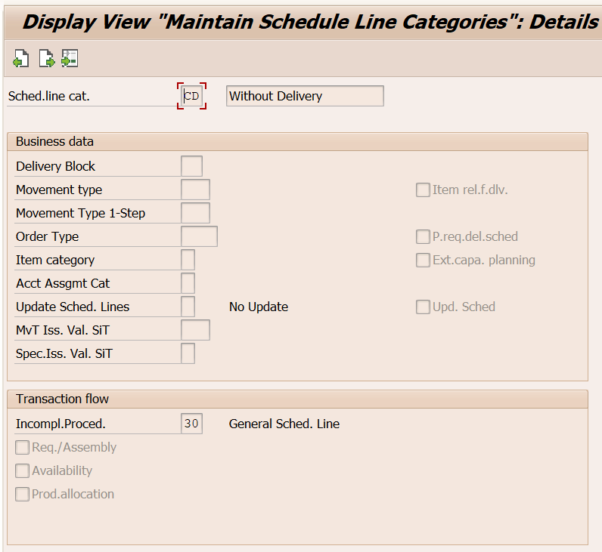

# 4. Billing Types(VOFA)

## 4.1 Invoice(ZF2)

## 4.2. ZBV(OUP Cash/ CC Invoice)

## 4.3 Downpayment request(ZFZ)

## 4.4 Credit Memo(ZG2)

## 4.5 Intercompany Invoice(ZIV)

## 4.6 Invoice Cancellation(ZS1)

